**Project: SKY NET**

**Interface Control Document for the Artificial Intelligence (AI) Unit**

**Presented by**

**Participating Members:**

Andrew Thomas, Spenser Gorenflo, Connor Hill

Dhwanil Desai, Nisarg Shah, Miles Medearis, Yaya Nedd, Mariana Villalabeitia Arenas

Dylan Huss, Bria Booth, Suleyman Gokdemir

|  |  |  |
| --- | --- | --- |
| **Rev.** | **Date** | **Revision Notes** |
| 0 | 12/05/2021 | Initial release by FIT, new document created |
| 1 | 12/09/2021 | Modified Reference Document Names |

***Student Contribution:***

|  |
| --- |
| All students contributed equally to the development of this AI Sub-system Specification. |

***Table of Contents:***

Table of Contents

***1.*** ***Scope*** 4

***2.*** ***Applicable Documents*** 5

***3.*** ***Interface Specification Definition*** 5

# ***Scope***

****This preliminary component specification has been created for educational purposes. It does not capture the full component specifications required to develop the project.

* 1. Identification

The intent of this document is to provide an electrical and computational description of the interfaces related to the AI, machine learning, sub-system of the AUAV project. This document will contain enough information to plan the electrical and computational items needed to successfully connect electrically and decipher computationally.

* 1. Sub-system Overview

The AI, machine learning, sub-system described in this document contains a set of optical imaging sensors necessary to the flight operations of an AUAV. These sensors include optical and position sensors to detect the AUAV position. There is also an onboard processor operations to interface with the AUAV flight computer. An electrical connection terminal strip is provided for ease of connection to the rest of the AUAV electrical system.

* 1. Document Overview

This document is intended to be used by the AUAV maintenance team to aid in simple reliable electrical and computational connection and derivation of the AI, machine learning, sub-system to the AUAV airframe. Within this ICD, Section 1 covers document identification, sub-system overview, document overview, order of precedence, and change of authority. Section 2 identifies all applicable documents. Section 3 identifies the specific interface definitions, physical characteristics and processing between the AI sub-system, the flight computer, the power, and the propulsion sub-system within the AUAV. Section 4 contains notes and Section 5 contains the appendixes. A section not relevant to a specific interface may be marked as “Not applicable (N/A)”.

* 1. Order of Precedence

In the event of a conflict between the content of this ICD and the references cited, the requirements will always take precedence. Nothing in this ICD supersedes applicable laws and regulations unless a specific exemption has been obtained or identified.

* 1. Change Authority

The approval authority for the ICD is the Area Code Diversity Collective Configuration Control Board (CCB). Changes to this ICD must be coordinated with the SECURE IPT and both sides of the interface and also, approved by the CCB.

# ***Applicable Documents***

* 1. Government Documents

MIL-STD-3046 (DI-SESS-81876) Interface Control Document (ICD) 28 February 2013

* 1. Non-Government Documents

Project SKYNET Design Dossier Rev 3 December 09, 2021

Project SKYNET System Specification Rev 3 December 09, 2021

Project SKYNET Sub-System Specification Rev 3 December 09, 2021

Project SKYNET Component Specification Rev 3 December 09, 2021

# ***Interface Specification Definition***

* 1. Interface Overview

J2 is the main electrical terminal strip. This connection point contains all the electrical connections for input voltage, command data input and sensor data output. The only additional electrical connection is the machine learning (AI) Sub-system which has a physical interface with the Master Control function.

* 1. Interface Descriptions
     1. J2 Terminal strip

The electrical terminal strip contains all the input voltage points to power the internal components of the AI Sub-system. This input voltage point interfaces with the propulsion and power sub-system on the AUAV. This terminal strip also contains all the command data input and the sensor data output lines that interface with the AUAV flight computer. The terminal strip screws are #2 Philips.

* 1. Interface Data
     1. J2 electrical interface data

|  |  |
| --- | --- |
| Pin | Description |
| J2-1 | 12 VDC input |
| J2-2 | 12 VDC return |
| J2-3 | Machine Learning Data Processor |
| J2-4 | Data from flight computer |
| J2-5 | Sensor data to flight computer |
| J2-6 | Data Sync + |
| J2-7 | Data Sync - |
| J2-8 | Spare |
| J2-9 | Spare |
| J2-10 | Spare |
| J2-11 | Spare |
| J2-12 | Spare |
| J2-13 | Spare |
| J2-14 | Spare |
| J2-15 | Spare |
| J2-16 | Spare |
| J2-17 | Spare |

* + 1. Interconnect Drawing

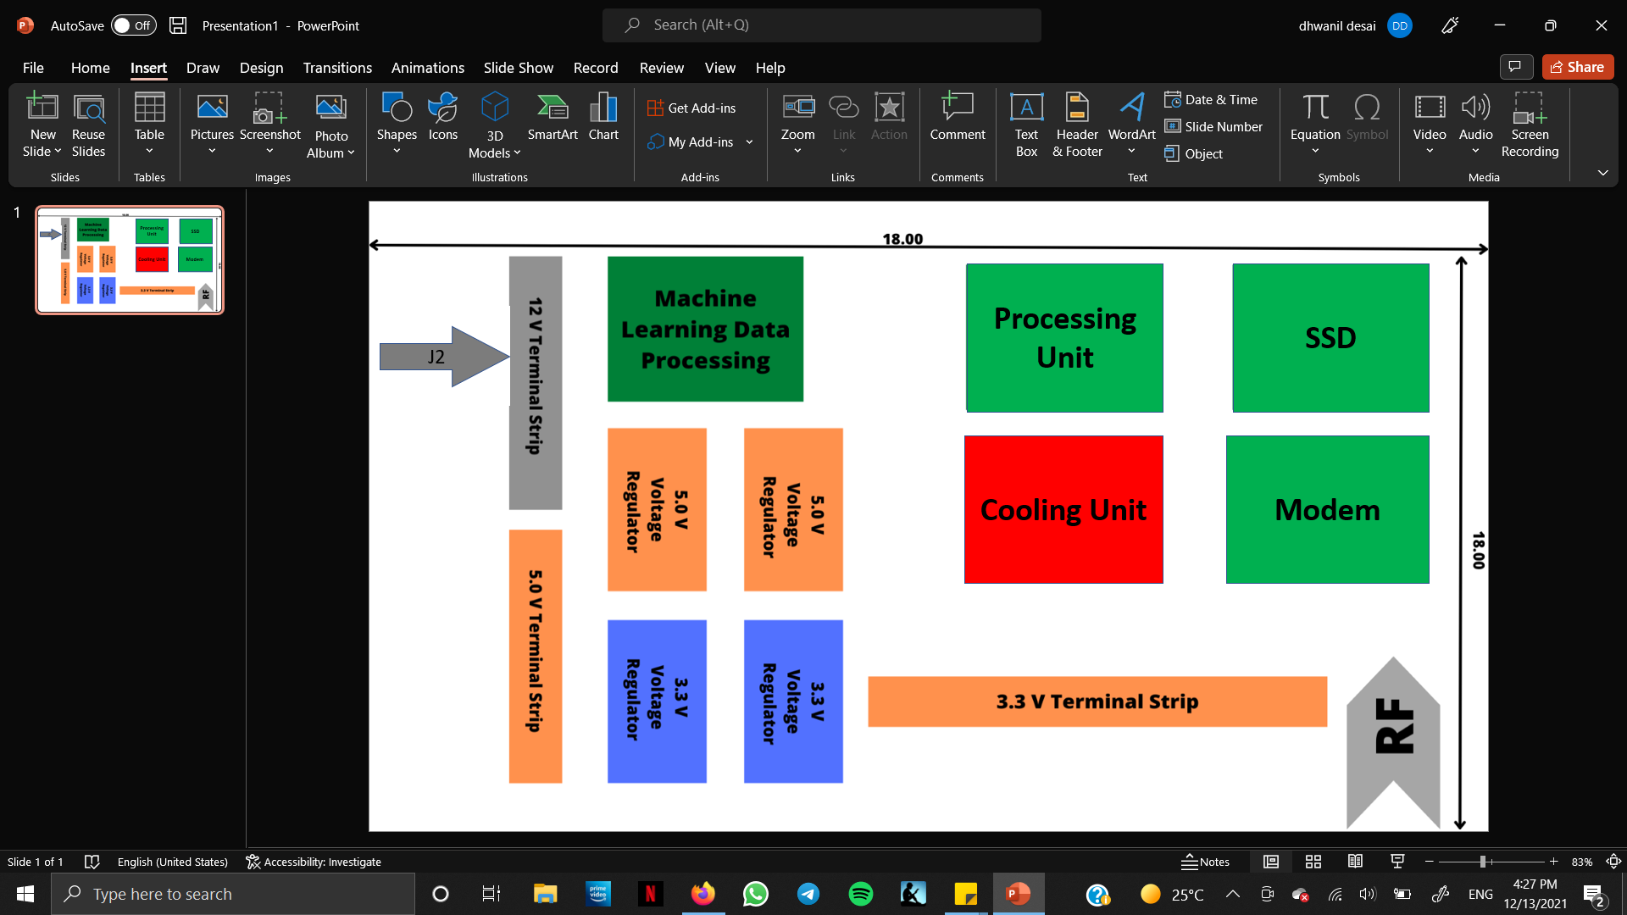

Figure 1: J2 Interconnect Drawing

* + 1. Structural/Mechanical

The AI Sub-system is comprised of individual components, electrical wiring, and direct computation, that connects each of these items together. All these components are software installed on an Central Processing Unit (CPU).

* + 1. Installation, Removal, and Update
       1. Installation
       2. The installation process shall begin with uploading the AI software to the onboard AUAV computer. This software will be provided on a secure external hard drive.
       3. Removal

The AI software can be removed using an built in uninstall feature, or by removal of the CPU card.

* + - 1. Update

Regular sub-system updates will be provided by use of a secure external hard drive. Update installations will occur automatically once connected with the hard drive.

* + - 1. Cooling

Additional cooling may be required for this sub-system as the AI Sub-system uses more power and hence heat production. A more sufficient airflow will generate enough cooling for proper operation.

* + 1. Connectivity

The table below shows the mating connector types and manufacturer numbers that can be used to connect to the AI Sub-system. The part numbers listed are representative parts. Other equivalent parts are acceptable, and they will accomplish the same function.

|  |  |  |  |
| --- | --- | --- | --- |
| Connection | Type | Manufacturer | Part Number |
| J2 Terminal strip (All) | Terminal | 3M | 94880 |

# ***Notes***

Not applicable (N/A)

# ***Appendixes***

* 1. Abbreviations and Acronyms

|  |  |
| --- | --- |
| Abbreviation | Description |
| AUAV | Autonomous Unmanned Aerial Vehicle |
| AI | Artificial Intelligence |
| CCB | Configuration Control Board |
| COTS | Commercial Off the Shelf |
| GPS | Global Positioning System |
| ICD | Interface Control Document |
| Lbs | Pounds |
| SMA | Subminiature version A |
| VDC | Volts Direct Current |
| SSD | Solid state drive |
| RF | Radio frequency |